Ceramic Fiber
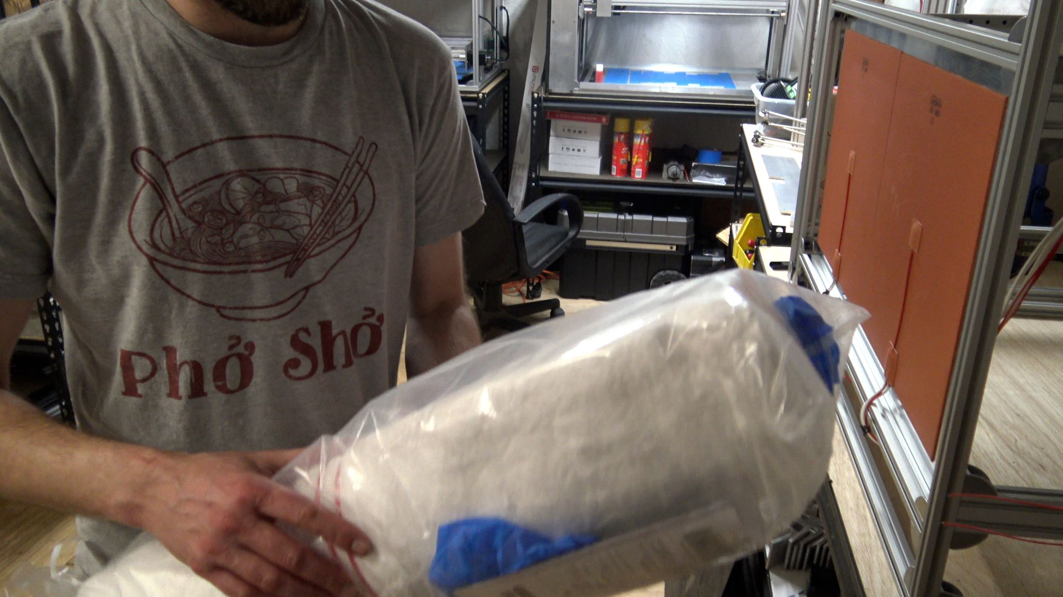

Ceramic fibres are made from inorganic materials, primarily aluminium oxide (Al2O3) and silicon dioxide (SiO2), leading to very high thermostability. Under normal circumstances standard ceramic fibres can be applied at temperatures up to 1260 °C. By adding small amounts of, e.g., zirconium oxide (ZrO2) the application temperature can be increased to approx. 1600 °C.

Ceramic fiber products have high tensile strength characteristics that can withstand physical abuse and vibrations and can be used for most applications up to 2,300°F, particularly useful for insulation material.

Buy Ceramic Fibre
Amazon

Flame resistant ceramic fibres
Ceramic fibres are mainly used in the following applications:

fire barrier fabrics: fire safety curtains, engine insulation, machine/workplace isolation

thermal insulation: bulkhead fire insulation and aerospace for engine and fuselage fire insulation.

blends with organic fibres: flexible fire barrier fabrics for aircraft seating and contract furnishing fire barriers or blockers.

Is ceramic fiber dangerous?
The ceramic fibers in the manufactured product are extremely sharp and can cause skin and upper respiratory irritation. Skin irritation can be caused if the broken ends of the ceramic fibers become embedded in the skin.

What does a ceramic blanket do?
A ceramic fiber blanket can be used for a number of purposes and equipment. These include applications in boilers, furnaces, generators, kilns and turbines. In smaller applications, the ceramic fiber blanket can be cut up and attached as gaskets, seals and insulators for specific purposes.

Related Content
3D Distributed
3D Printers
WorkHorse 3D Printer
WorkHorse 3D Printer BOM
Build Plate
Heated Bed
Ceramic Fibre
Keenovo Silicone Heat Pad
Build Plate
Build Plate Options

Also See
WorkHorse BOM
Igus Lead Screw
Linear Rails
WorkHorse Frame
WorkHorse Motors
WorkHorse Printer: Users Guide
Duet Wifi Setup
Duet 2 vs Duet 3
WorkHorse 3D Printer
Recommended Print Settings
3D Distributed

Firmware Files
config.g
Homeall.g
homex.g
Homey.g
Homez.g

Duet 3 Mainboard Setup
Duet3D YAT Commands
Reverse Motor Direction

Duet Wifi
Duet Wifi Setup

